Scatter Gather Pattern Overview
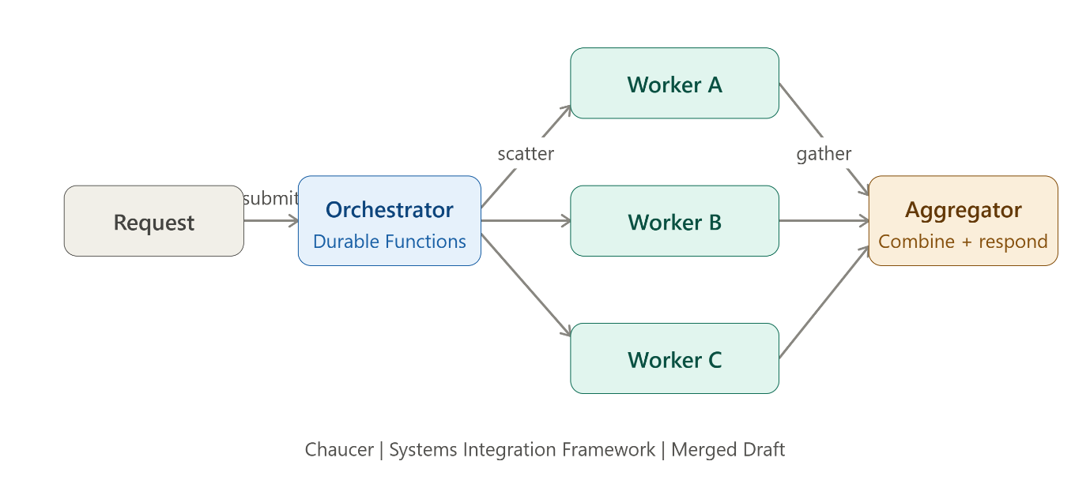
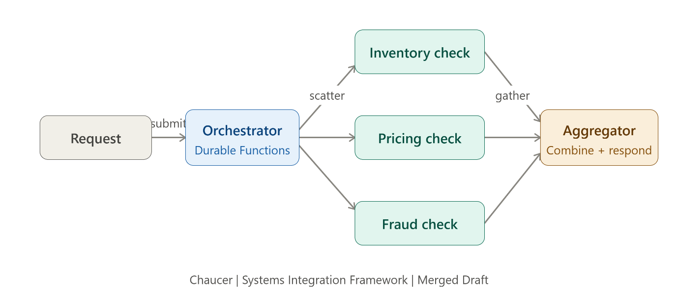

Scatter-Gather is a parallel processing pattern that sends work to multiple services simultaneously and combines the results into a single response, improving performance and scalability.
Scatter (Fan-Out): Send a request to multiple services in parallel.
Gather (Fan-In): Collect and combine all responses into one result.
Problem. A request needs results from several independent operations before it can complete.
Solution
An orchestrator sends requests in parallel (scatters), waits for responses, then aggregates them into a single output (result fans in to an aggregator).
Azure Components
- Orchestrator: Coordinates parallel execution (Durable Functions).
- Workers: Independent processing units (Azure Functions/Services).
- Aggregator: Combines results into a final response.
Implementation ways :
1. Azure Durable Functions
Best for parallel processing and workflow orchestration.
Examples: File processing, report generation, API aggregation.
2. Azure Logic Apps
Uses parallel branches to call multiple systems and merge responses.
Example: SAP + Salesforce + Internal API integration.
3. Azure Service Bus + Aggregator
Publishes work to multiple subscribers and consolidates responses.
Best for scalable, decoupled microservices.
Use When
- Tasks are independent.
- Parallel execution improves performance.
- All (or most) results are required before continuing.
Avoid When
- Tasks depend on each other.
- No combined response is needed.
- One task dominates overall processing time.
Risks & Considerations
- Handle timeouts and missing responses.
- Control concurrency to avoid throttling.
- Use batching for large-scale workloads.
Security
Authenticate once at the orchestrator and use Managed Identity for downstream services with least-privilege access.
Anti-Patterns
- Calling services sequentially instead of in parallel.
- Waiting indefinitely for all responses without a timeout strategy.
Common Pitfalls of the Scatter-Gather Pattern
- Waiting Forever for Responses
  - One slow or unresponsive service delays the entire process.
  - Always implement timeouts and fallback handling.
- Sequential Calls Instead of Parallel Calls
  - Services are invoked one after another, defeating the purpose of Scatter-Gather.
  - Ensure requests are executed concurrently.
- Too Much Parallelism
  - Sending hundreds of requests simultaneously can overload downstream systems.
  - Use throttling, batching, or concurrency limits.
- Ignoring Partial Failures
  - If one service fails, the entire aggregation may fail.
  - Design for partial results where appropriate.
- Poor Error Handling
  - Errors from worker services are not captured or surfaced clearly.
  - Log failures and provide meaningful error responses.
- Inconsistent Response Formats
  - Different services return data in different structures.
  - Standardize contracts before aggregation.
- Large Payload Aggregation
  - Combining huge responses can increase memory usage and latency.
  - Filter or summarize data before aggregation.
- Lack of Correlation Tracking
  - Difficult to trace related requests across multiple services.
  - Use correlation IDs for end-to-end monitoring.
- Ignoring Security Across Services
  - Multiple service calls may require different authentication methods.
  - Use Managed Identity or centralized authentication.
- Not Monitoring Performance
  - Slow worker services may go unnoticed.
  - Monitor response times, failures, and bottlenecks.
The biggest risks in Scatter-Gather are slow services, missing timeouts, excessive parallelism, partial failures, and poor observability. Proper error handling, throttling, monitoring, and correlation tracking are essential for a successful implementation.

